**Configure Amazon S3 Event Logging and Handling**

**Scenario:**

Need to create multiple S3 buckets, enable version control, server access logging, S3 encryption, public access, public website hosting, and will upload files to serve as a static website. Exchange of files with external customers, and to ensure that the documents use version control to protect them from accidental deletion.

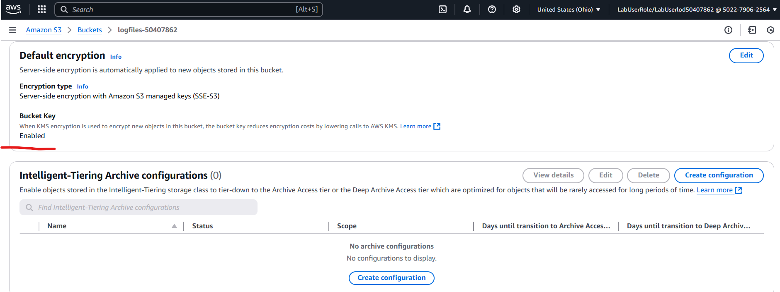

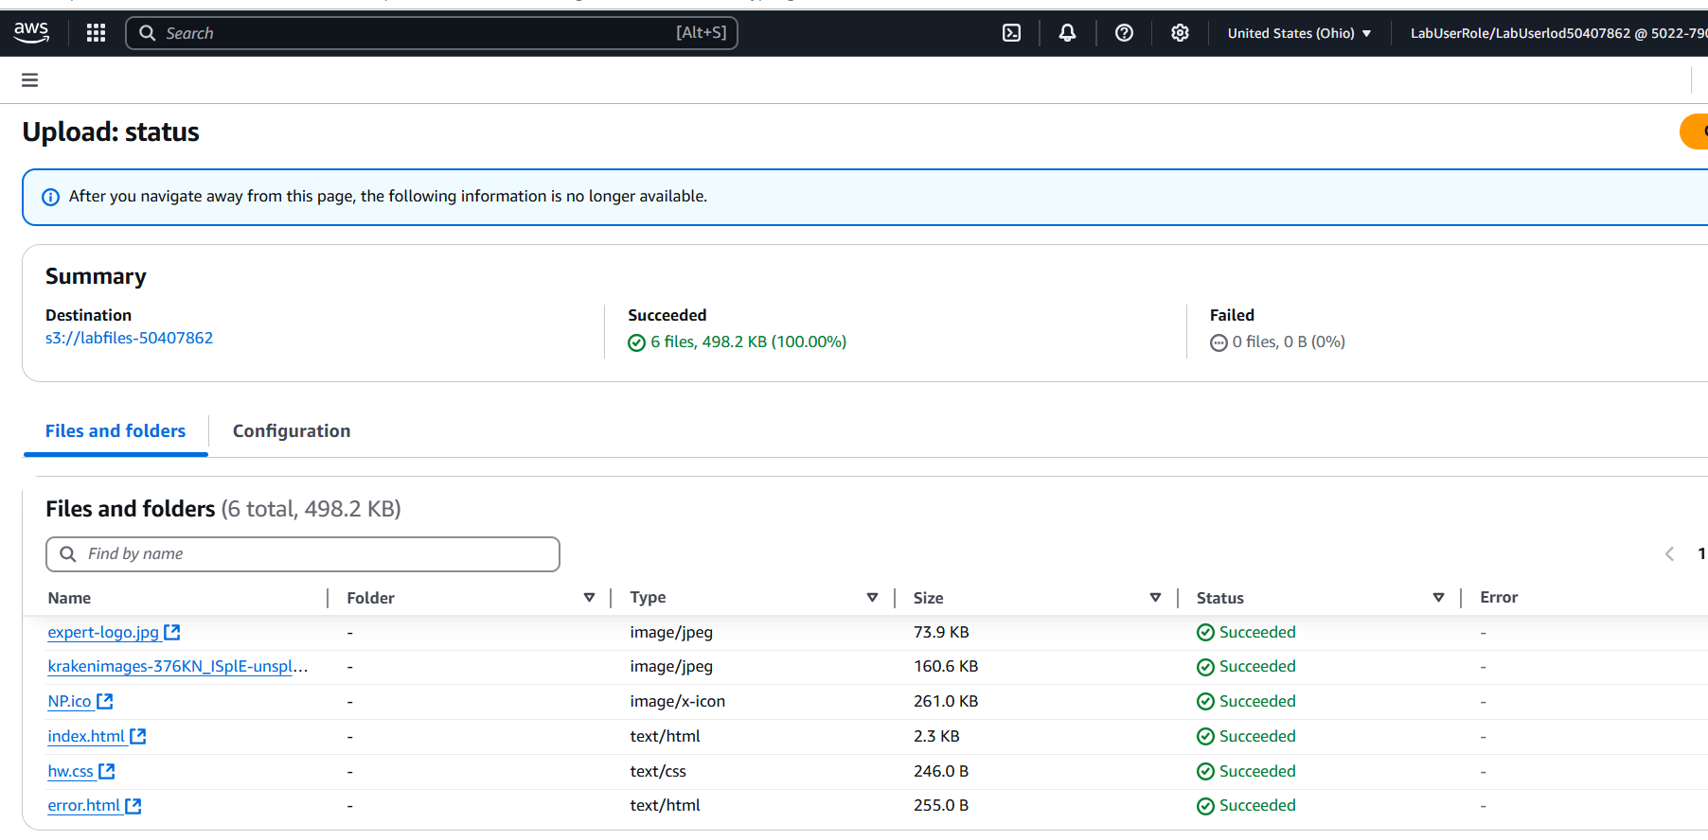

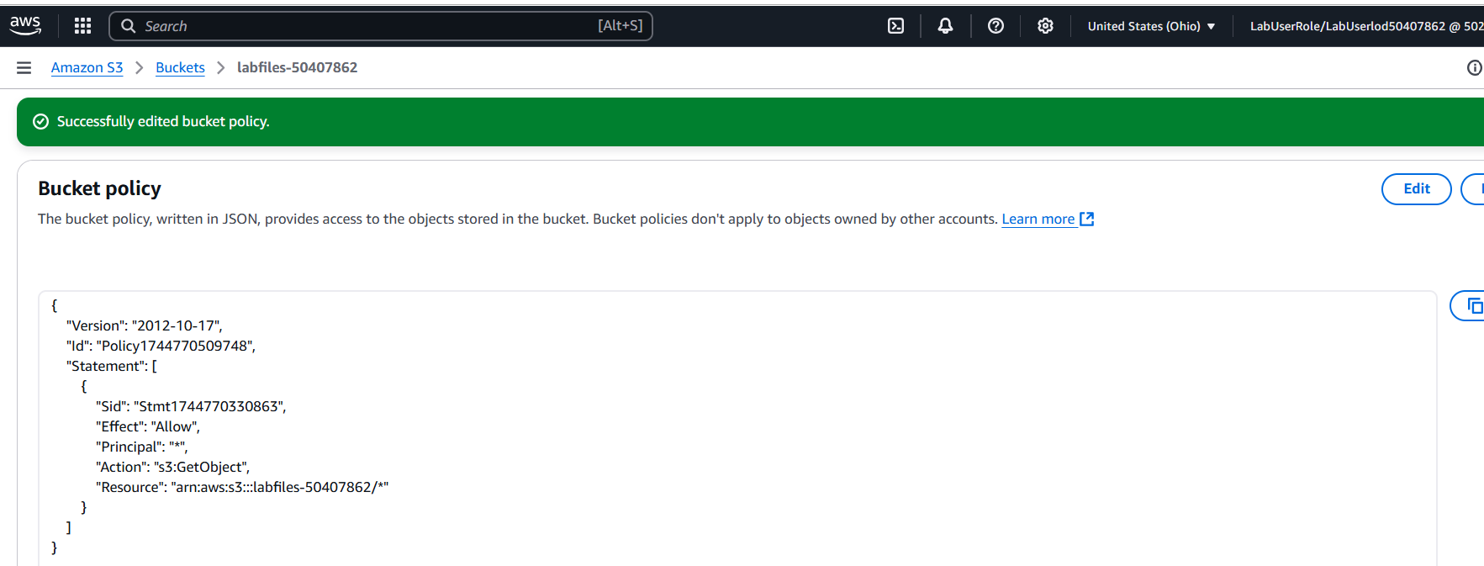

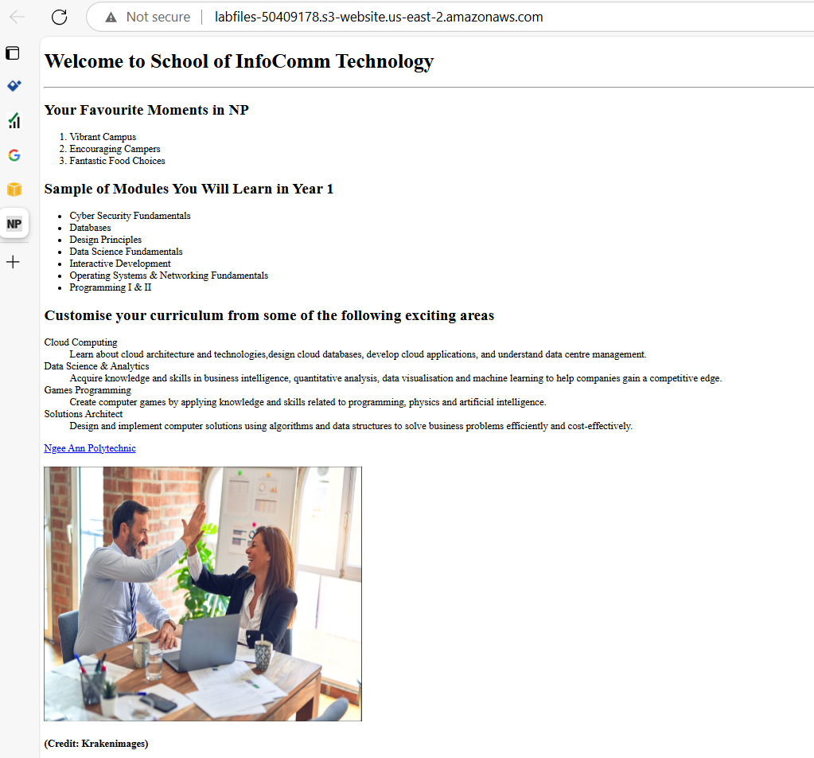

**Key Tasks performed:**

* Created S3 buckets to store content and log files.
* Enabled version control.
* Enabled server access logging.
* Enabled S3 encryption.
* Uploaded files to an S3 bucket.
* Set public permissions for files.
* Configured public access permission and website hosting.